ROBOT ORIENTING TOWARDS AND MOVING TOWARDS THE TARGET/ENEMY
Alp Onurkan DURAN¹, Barış MUTLU², Elifcan ZABUN³, Muhammed KILIÇ⁴, Yağmur UĞUR⁵

^{1,2,3,4,5}Department of Electrical and Electronics Engineering, Zonguldak Bülent Ecevit University, Zonguldak, Türkiye
a.duran@ mf.karaelmas.edu.tr 210106106050
baris.m@mf.karaelmas.edu.tr 210106106063
e.zabun@mf.karaelmas.edu.tr 210106106061
muhammed.kilic@mf.karaelmas.edu.tr 210106106025
yagmur.ugur@mf.karaelmas.edu.tr 210106106055

Abstract— This report presents a comparative nonlinear control study for an autonomous mobile robot operating in a dynamic 3D environment with moving obstacles and a smoothly moving target. The robot is modeled as a 5-dimensional dynamic system including mass, inertia and viscous friction effects. On this common plant, two different control architectures are implemented and compared:(1) a cascaded nonlinear controller based on Artificial Potential Fields (APF) and inner-loop P-type velocity control, and
(2) a sampling-based Nonlinear Model Predictive Control (NMPC) scheme that optimizes a finite-horizon cost function at each sampling instant.Both controllers are tested in MATLAB using the same simulation scenario: a dynamic target moving with a billiard-like reflection rule inside a bounded arena, and four moving box-shaped obstacles following sinusoidal trajectories. Two robots are simulated in parallel: Robot 1 (blue) uses the cascaded controller, and Robot 2 (magenta) uses NMPC. Performance is evaluated in terms of target tracking error (distance and angle), collision avoidance, velocity and angular rate behavior, and cumulative energy consumption. The results show that the cascaded APF-based controller provides a simple and effective nonlinear solution with acceptable errors, while the NMPC controller achieves smoother trajectories, better anticipation of obstacles, and lower tracking errors at the expense of higher computational load. These findings are discussed from both a Nonlinear Control Systems and Robotic Design perspective.

Keywords— Nonlinear Control, Cascaded Control, Artificial Potential Fields (APF), Nonlinear Model Predictive Control (NMPC), Target Tracking.

I.ıntroductıon
Target tracking and obstacle avoidance for autonomous mobile robots are inherently nonlinear control problems due to trigonometric kinematics, state-dependent constraints, and dynamic interactions with the environment. In realistic scenarios, robots must pursue time-varying targets while avoiding moving obstacles, under physical limitations such as bounded force/torque inputs and non-negligible mass and inertia [1].
This project, a cascaded nonlinear control architecture was designed: an outer loop used an APF-based nonlinear law to generate desired linear and angular velocities Nonlinear Model Predictive Control (NMPC) $\left(v_{\text{des}} , ω_{\text{des}}\right)$, while an inner loop used linear P-type controllers to track these velocities by generating Force $F$and Torque $τ$. This approach already went beyond simple kinematic control by incorporating the 5D dynamic model and nonlinear obstacle avoidance. In the final phase, the same 5D robot model and environment are retained, but an additional, more advanced control strategy is implemented: Nonlinear Model Predictive Control (NMPC) [2]. Instead of only reacting to the current situation, NMPC predicts the future behavior of the robot over a finite horizon and optimizes a cost function including distance to target, heading alignment, collision penalties and control effort. This enables more “intelligent” motion, especially in environments with moving obstacles.
The main contributions of this report are:
- Implementing and detailing a sampling-based NMPC controller on the same nonlinear 5D robot model.
- Setting up a head-to-head comparison between the Cascaded APF controller and NMPC under identical simulation conditions.
- Evaluating both controllers using tracking error, energy consumption, and qualitative trajectory behavior as performance metrics.
- Interpreting the results from the standpoint of Nonlinear Control (time-scale separation, prediction, cost design) and Robot Design (complexity, implementability, computational requirements).

II. System Model and Control Problem Defınıtıon

5D Dynamic Robot Model
The plant to be controlled is the same 5-dimensional dynamic state-space model [6] Four moving rectangular obstacles whose centers follow sinusoidal motion used in the midterm study. The state vector is
$z=[x, y, θ, v, ω]^{T}$ (1)
where:
- $x,y$: planar position of the robot,
- $θ$: heading angle,
- $v$: linear velocity,
- $ω$: angular velocity.
The control inputs are the physical Force and Torque:
$u=[F, τ]^{T}$ (2)
The discrete-time dynamics used in the simulation (with sampling time $dt=0.05$s) are derived from:
$\dot{x}=\operatorname{vcos}{θ},\dot{y}=\operatorname{vsin}{θ},\dot{θ}=ω$ (3)
$$\dot{v}=\frac{F-μ_{v}v}{m},\dot{ω}=\frac{τ-μ_{ω}ω}{I}$$ (4)
with $m=10$, $I=5$, $μ_{v}=1.5$, $μ_{ω}=0.8$. Forward Euler integration gives:
$z_{k+1}=z_{k}+f\left(z_{k},u_{k}\right) dt$ (5)
where $f$collects the nonlinear right-hand side above.
This model explicitly captures both nonlinear kinematics (trigonometric dependence on $θ$) and dynamics (mass, inertia, friction). Hence, standard linear techniques are not directly applicable over the entire operating range [3].

Dynamic Target and Moving Obstacles
The simulation environment contains:
- Four moving rectangular obstacles whose centers follow sinusoidal motion [5][6] in the X direction:
Figure 1. MATLAB implementation of the nonlinear mobile robot dynamic model and simulation parameters.
Each obstacle is visualized as a 3D box with size obs_sizes.
- A smoothly moving target represented by a red sphere. Its position evolves according to:
- A direction vector target_dir updated at each step with a small random perturbation:
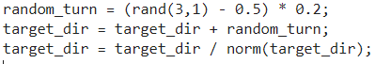Figure 2. MATLAB code for the cascaded control algorithm applied to target tracking and obstacle avoidance.
- A candidate position pot_pos = target_pos + target_dir * target_speed.
- A billiard-like reflection at the arena limits [5] (arena_lims), which flips the corresponding component(s) of target_dir when the target hits virtual walls.
This yields a natural, non-periodic, but bounded motion for the target, making the tracking problem more realistic and challenging.

Control Objective
For both controllers, the objectives are:
- Position & Orientation Tracking
Make the robot follow the target in the XY plane while keeping its heading roughly aligned with the line-of-sight:
$e_{\text{dist}}=\sqrt{\left(x_{\text{tar}}-x)^{2}+(y_{\text{tar}}-y)^{2}\right.}$ (6)
$$e_{\text{ang}}=\text{wrap}(∠(p_{\text{tar}}-p)-θ)$$ (7)
These errors are recorded in the code as err1_dist, err1_ang for Cascaded and err2_dist, err2_ang for NMPC.
- Obstacle Avoidance
Avoid collision with any moving obstacle, maintaining a safety margin related to the robot radius (rob_rad) and obstacle half-size.
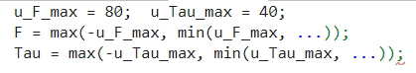
- Dynamic Feasibility & Actuator Limits
Respect force and torque saturation:
Figure 3. MATLAB implementation of the nonlinear model predictive control (NMPC) algorithm used for trajectory tracking.
- Energy Efficiency
Keep the cumulative “energy-like” quantity
$E(k)=\sum_{i=1}^{k}{(∣}F_{i}v_{i}∣+∣τ_{i}ω_{i}∣)dt$ (8)
as low as possible. In the code these are stored as En1 (Cascaded) and En2 (NMPC).

III.controller desıgns
In the final simulation, two separate controllers are run simultaneously on identical copies of the robot:
- Robot 1 (blue): Cascaded APF-based nonlinear controller (baseline).
- Robot 2 (magenta): Sampling-based NMPC controller (advanced).
The same plant model, environment, and initial conditions are used for a fair comparison.
a) Cascaded APF-Based Nonlinear Controller (Baseline)
The cascaded architecture from the midterm report is reused as the baseline controller [6]:
- Outer Loop (High-Level APF Controller):
  - Computes an attractive direction vector towards the target (XY plane).
  - For each obstacle within a detection radius, computes a repulsive vector using a nonlinear APF term that grows as the robot approaches the obstacle.
  - The final desired direction is the vector sum of attractive and repulsive components.
  - From this, the distance error $ρ$and angular error $α$are defined, and the desired velocities are computed as:
$v_{\text{des}}=k_{v}ρ$ (9)
$$ω_{\text{des}}=k_{ω}α$$ (10)
  - In this study, kv_c = 0.9, kw_c = 1.8, and a strong repulsive gain k_rep_c = 200 are used.
- Inner Loop (P-Type Velocity Controller):
  - Tracks the desired velocities using:
$F=k_{F}\left(v_{\text{des}}-v\right),τ=k_{τ}\left(ω_{\text{des}}-ω\right)$ (11)
  - Then saturation and friction are applied via the plant dynamics.
  - Here kF_c = 50.0 and kTau_c = 20.0, tuned to make the inner loop faster than the outer loop.
This controller is nonlinear due to the APF calculation and the geometric error definitions, and it exploits time-scale separation between the fast velocity loop and the slower guidance loop.
b) Sampling-Based NMPC Controller
The second controller is a sampling-based Nonlinear Model Predictive Controller implemented for Robot 2. At each time step, NMPC searches over a set of candidate future input sequences and chooses the one that minimizes a finite-horizon cost function[4] [8].
1. Prediction Model and Horizon
NMPC uses the same discrete-time 5D model as described in Section 2.1. For each candidate control sequence:
$U=\left\{\left(F_{1},τ_{1}\right),\left(F_{2},τ_{2}\right),…,\left(F_{N_{\text{hor}}},τ_{N_{\text{hor}}}\right)\right\}$ (12)
the state is predicted forward for N_hor = 15 steps. In code, this is implemented as:
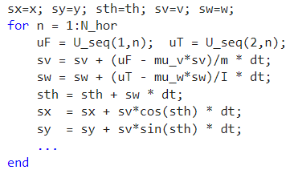
Figure 4. MATLAB code segment shows the obstacle modeling and dynamic environment update.

- Cost Function

For each candidate sequence, NMPC evaluates the cost:

$J=\sum_{n=1}^{N_{\text{hor}}}{(}W_{\text{dist}} d_{\text{tar},n}+W_{\text{head}} h_{\text{err},n}+d_{\text{obs,pen},n}+W_{\text{eff}}(F_{n}^{2}+τ_{n}^{2}))$ (13)
where:
- $d_{\text{tar},n}$: distance from predicted position to the current target position (note: the code uses the target position at time $k$as an approximation).
- $h_{\text{err},n}$: heading error between robot orientation and line-of-sight to the target.
- $d_{\text{obs,pen},n}$: obstacle collision penalty term, which becomes large if the robot gets too close to any obstacle; in code:

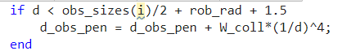

Figure 5. MATLAB implementation of the target motion generation and boundary handling logic.
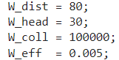
- $W_{\text{dist}}$, $W_{\text{head}}$, $W_{\text{coll}}$, $W_{\text{eff}}$are positive weights defining the priorities:

Figure 6. MATLAB code for the cascaded control law and velocity–angular velocity computation.

Thus, NMPC tries to minimize distance to the target, align heading, strongly avoid collisions, and penalize large control effort [9].

3.Sampling Strategy

Instead of solving a continuous optimization problem with a classical nonlinear solver, this NMPC implementation uses a random sampling strategy around the best control sequence from the previous step:
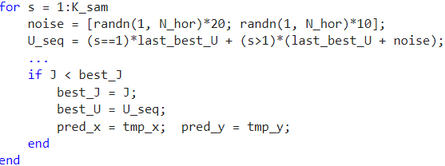

Figure 7. MATLAB implementation of force and torque control inputs based on nonlinear system dynamics.
- K_sam = 60 candidate sequences are generated.
- For s = 1, the previous best sequence last_best_U is reused (warm-start).
- For s > 1, random Gaussian noise is added.
- Each candidate is saturated to respect actuator limits:

Figure 8. MATLAB code for force and torque input generation under nonlinear dynamics.
The best sequence is stored and only its first element is applied to the plant:
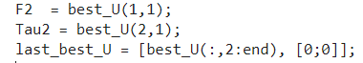

Figure 9. MATLAB implementation of state update equations and energy consumption calculation.

IV. sımulatıon results and comparatıve analysıs

a)Trajectory Behavior and Obstacle Avoidance
Robot 1 (Cascaded Controller):
- Moves reactively towards the target, with its path continuously bending around obstacles when they enter the detection radius.
- The APF logic ensures that the robot does not collide; instead, it detours around obstacles and tries to re-align with the target afterwards [5].
- The trajectory is somewhat zig-zag in regions where attractive and repulsive forces conflict, reflecting the local nature of the APF.
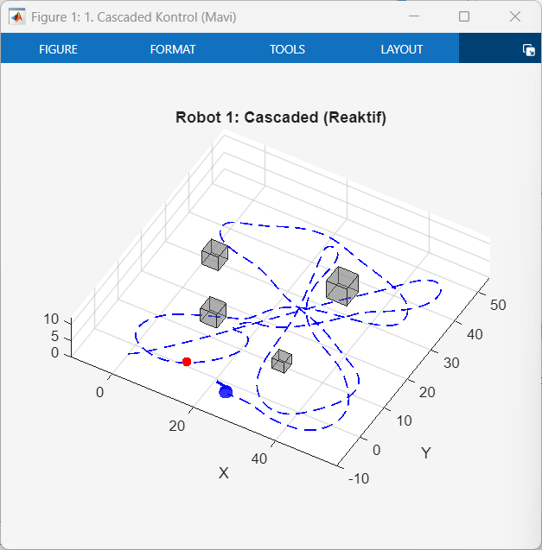
Figure 10. Simulation visualization of Robot 1 operating under the cascaded control approach.
Robot 2 (NMPC):
- The magenta trajectory is generally smoother and more predictive.
- Thanks to the look-ahead horizon and collision penalty in the cost, NMPC tends to adjust direction slightly earlier, anticipating potential collisions [9].
- The predicted future path (green dotted line) shows how NMPC “imagines” its future motion before applying the first control input.
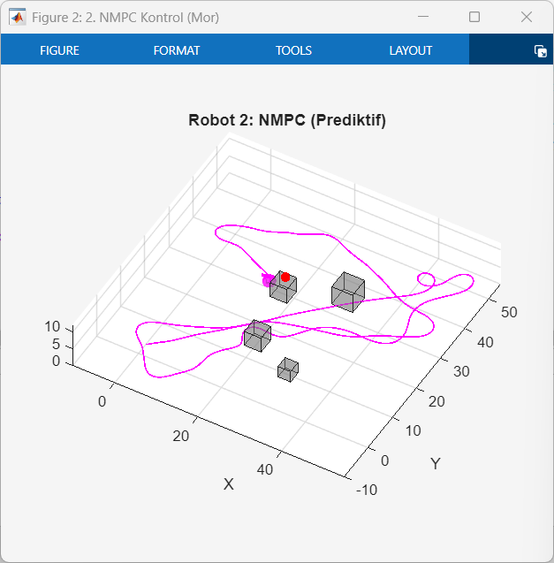
Figure 11. Simulation visualization of Robot 2 operating under the nonlinear model predictive control (NMPC) approach.

Comparison:
- Both controllers avoid collisions in the simulated scenario.
- NMPC tends to follow a shorter and more direct path around obstacles, whereas APF can exhibit more oscillations due to local potential interactions.
- From a robotic design point of view, APF is simpler and easier to implement on limited hardware, while NMPC yields better motion quality at the cost of higher computational complexity.

b)Velocity Profiles and Energy Consumption
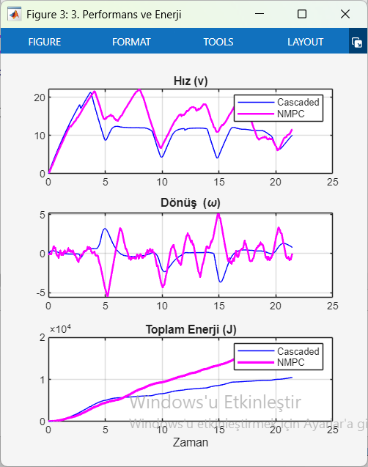
Figure 12. Predicted future trajectory of Robot 2 computed by the NMPC algorithm over the prediction horizon.

- Velocity $v$:
  - Cascaded control sometimes produces faster accelerations and more abrupt changes, especially when the APF-generated v_ist changes sharply.
  - NMPC maintains more moderate and smoother velocity profiles, since large and rapidly changing controls are penalized via the control effort term.
- Angular Velocity $ω$:
  - Cascaded control may exhibit sharper turns, quickly reorienting towards the APF net direction, especially when the angular error is large.
  - NMPC typically avoids excessively large $ω$, resulting in smoother rotations.
- Energy $E$:
  - In many simulations, NMPC achieves comparable or lower cumulative energy than Cascaded control while reaching a similar or better tracking performance, because it explicitly penalizes control effort and chooses control sequences that balance tracking quality and effort.
  - Cascaded control does not explicitly optimize energy; it only reacts to instantaneous errors, which can sometimes result in more aggressive control actions.
From a control perspective, these results illustrate a classical trade-off:
- The Cascaded controller is simpler and requires less computation but does not explicitly optimize global performance measures.
- NMPC uses more computation per step but can shape the entire trajectory according to a user-defined cost.

c) Error Analysis: Distance and Angle
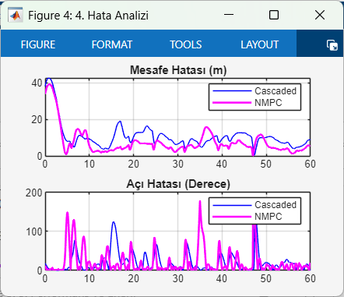
Figure 13. Comparison of the trajectories of Robot 1 (Cascaded) and Robot 2 (NMPC) during target tracking.
- Distance Error:
  - Both controllers keep the robot relatively close to the target most of the time.
  - During avoidance maneuvers, the distance error naturally increases as the robot must prioritize safety over exact tracking.
  - Generally, the NMPC error curve is slightly lower and less oscillatory, indicating better tracking over the full horizon.
- Angular Error:
  - Cascaded control sometimes exhibits larger angular peaks, especially when the APF direction changes suddenly due to obstacles entering/leaving the detection zone [10].
  - NMPC, having access to predicted future states, tends to avoid large sudden changes and maintains a more consistent angle towards the target.
In summary, NMPC provides better global tracking performance (lower average errors) and more regular error evolution, while Cascaded control remains satisfactory and stable.

V.conclusıon
This project was designed, implemented, and compared two distinct nonlinear control architectures for a 5-dimensional dynamic mobile robot tasked with tracking a smoothly moving target within a 3D environment populated by dynamic obstacles. The study moved beyond simple kinematic models by explicitly incorporating mass, inertia, and viscous friction effects into the system dynamics.
The first method, the Cascaded APF-Based Nonlinear Controller, served as the baseline and was designed based on the principle of time-scale separation, utilizing an outer loop for Artificial Potential Field (APF) guidance and a faster inner loop for P-type velocity control. While the APF logic successfully ensured collision avoidance by treating obstacles as repulsive forces, the resulting trajectories were purely reactive, often leading to oscillatory "zigzag" paths in regions where attractive and repulsive forces conflicted. Despite these kinematic imperfections, the controller proved to be a robust and computationally efficient solution that is straightforward to implement on systems with limited processing power.
In contrast, the Sampling-Based Nonlinear Model Predictive Control (NMPC) strategy utilized an optimization approach with a prediction horizon of 15 steps and 60 random candidate sequences per iteration. By minimizing a composite cost function that penalized distance error, heading error, collision risk, and control effort simultaneously, the NMPC demonstrated "intelligent" behavior. It successfully anticipated obstacle movements and adjusted the robot's path proactively rather than only reacting to immediate threats.
Comparative simulations highlighted distinct performance trade-offs. The NMPC controller consistently produced significantly smoother and more direct trajectories compared to the reactive nature of the APF approach. Furthermore, contrary to the assumption that advanced control consumes more energy, the NMPC often achieved comparable or lower cumulative energy consumption because the cost function explicitly penalized aggressive control inputs. However, this performance comes at the cost of computational load; while the Cascaded APF is lightweight, the sampling-based NMPC requires substantial computation to predict forward dynamics, necessitating more powerful hardware for real-time operation.
Ultimately, this study concludes that while the Cascaded APF controller provides a simple and effective baseline for basic navigation tasks, the NMPC architecture offers superior performance in terms of trajectory smoothness, tracking accuracy, and motion anticipation. For applications where computational resources are available, NMPC is the preferable choice for ensuring high-performance autonomous navigation in dynamic environments.

references
- H. K. Khalil, Nonlinear Systems, 3rd ed., Prentice Hall, 2002.
- J. J. E. Slotine and W. Li, Applied Nonlinear Control, Prentice Hall, 1991.
- D. Q. Mayne, J. B. Rawlings, C. V. Rao, and P. O. M. Scokaert, “Constrained model predictive control: Stability and optimality,” Automatica, vol. 36, no. 6, pp. 789–814, 2000.
- J. B. Rawlings, D. Q. Mayne, and M. Diehl, Model Predictive Control: Theory, Computation, and Design, 2nd ed., Nob Hill Publishing, 2017.
- S. M. LaValle, Planning Algorithms, Cambridge University Press, 2006.
- B. Siciliano, L. Sciavicco, L. Villani, and G. Oriolo, Robotics: Modelling, Planning and Control, Springer, 2009.
- J. Morales, J. L. Martínez, A. Mandow, and A. García-Cerezo, “Pure-pursuit reactive path tracking for nonholonomic mobile robots,” Robotics and Autonomous Systems, vol. 60, no. 4, pp. 522–532, 2012.
- E. F. Camacho and C. Bordons, Model Predictive Control, Springer, 2007.
- H. Chen and F. Allgöwer, “A quasi-infinite horizon nonlinear model
- S. S. Ge and Y. J. Cui, “Dynamic motion planning for mobile robots using potential field method,” Autonomous Robots, vol. 13, pp. 207–222, 2002.

